第二章 安装
1、升级 pip
python -m pip install --upgrade pip
2、安装 flask
使用pip install flask安装Flask
3.6版本：
找到python3.6的pip.exe的目录，比如我的电脑在C:\Users\afeng\AppData\Local\Programs\Python\Python36\Scripts，DOS界面切换到该目录，输入命令pip install flask
C:\Users\afeng\AppData\Local\Programs\Python\Python36\Scripts>pip install flask
Collecting flask
Using cached Flask-0.12.2-py2.py3-none-any.whl
Collecting Jinja2>=2.4 (from flask)
Using cached Jinja2-2.10-py2.py3-none-any.whl
Collecting itsdangerous>=0.21 (from flask)
Using cached itsdangerous-0.24.tar.gz
Collecting click>=2.0 (from flask)
Using cached click-6.7-py2.py3-none-any.whl
Collecting Werkzeug>=0.7 (from flask)
Using cached Werkzeug-0.14.1-py2.py3-none-any.whl
Collecting MarkupSafe>=0.23 (from Jinja2>=2.4->flask)
Using cached MarkupSafe-1.0.tar.gz
Installing collected packages: MarkupSafe, Jinja2, itsdangerous, click, Werkzeug
, flask
Running setup.py install for MarkupSafe ... done
Running setup.py install for itsdangerous ... done
Successfully installed Jinja2-2.10 MarkupSafe-1.0 Werkzeug-0.14.1 click-6.7 flas
k-0.12.2 itsdangerous-0.24
2.7 版本
找到python2.7的pip.exe的目录，比如我的电脑在C:\Python27\Scripts，DOS界面切换到该目录，输入命令pip install flask。
- 检测是否安装成功
在Python命令行里输入import flask，如果没有报错，则安装成功。
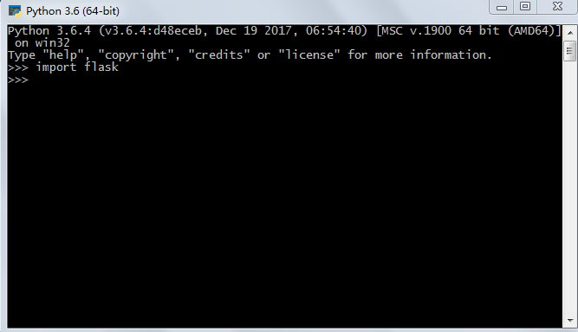
- 安装的目录
以python3.6为例子，安装完以后，在目录
C:\Users\afeng\AppData\Local\Programs\Python\Python36\Lib\site-packages下可以找到
flask相关文件。

